Kids Islamic Hub:AI and Flutter based kids Islamic learning android application
_________________________________

Final Year Project Report

by

Shawana Ahmad | 085708
Manahil Sohail | 085686
Sumaira Haider | 085655

Project Advisor:
Prof. Muhammad Faiyaz

Faculty of Computing & Information Technology,
University of the Punjab, Lahore, Pakistan.(2022-26)
Kids Islamic Hub--AI and Flutter based kids Islamic learning android application
Executive Summary
Kids Islamic Hub -An Android E-Learning platform for kids built to make learning Tajweed, Supplications, and Manners easier for kids.The app offers a complete learning experience with access to audio lessons,visuals, voice recording for pronunciation matching with teacher’s voice,and even an AI feedback system which analyzes the user’s audio and provides feedback of tajweed lessons in the form of stars and badges.
The project proposal explains the idea of solving the problem of learning tajweed for kids without accessing a live Quran teacher. The Software Requirement specification(SRS) describes what the system should do such providing audio playback for all the modules of tajweed, manners, and supplications as well as providing recording option for end users to record their voice for pronunciation correction and providing a feedbck of the audio.it also explains basic system requirements like speed,usability, and data safety.
The Software Design Specification explains how the system is designed and how different parts work together.The system uses modern technologies like flutter and supabase, for offline data storage system use sqlite database and for feedback system uses an AI model.
Overall Kids Islamic Hub is an easy to use system that helps user to learn islamic teachings in an easy way.

Final Year Project Overview
Final Year Project Title: AI and Flutter based kids Islamic learning application
Sr. No | Roll no | Names | signature
1. | 085708 | Shawana Ahmad
2. | 085686 | Manahil Sohail
3. | 085655 | Sumaira Haider
Table 1:Project Proposal Summary
Final Year project Goals
- Design and develop an interactive mobile application for children.
- Create a digital platform for learning basic Islamic teachings.
- Integrate AI features for improving Tajweed learning and feedback.
- Develop the application using Flutter.
- Provide an engaging and child-friendly learning experience.
Final Year project Objectives
- Design and implement an interactive UI using Figma and flutter.
- Provide offline access using SQLite.
- Ensure secure authentication using supa-base.
- Integrate AI models for pronunciation analysis.
- Implement a reward system to increase user engagement.
- Enable audio playback and recording features.
- Provide admin access for managing learning modules.
FYDP Success Criteria
- The application functions smoothly without crashes and all modules (Tajweed, Supplications, Manners) operate correctly.
- User authentication is securely implemented using Supa base.
- Offline access works properly through SQLite, allowing users to access content without the internet.
- The AI-based pronunciation feedback system accurately analyzes and provides results to users.
Assumptions:
- Basic smartphone access among users.
- Internet access for updates or audio download.
Risks and Obstacles:
- Ensuring correct pronunciation through AI
- Delivering religious content in a fun way.
- Managing large audio files.
Organization Address: FCIT, University of the Punjab, Lahore, Pakistan
Target End Users: kids
Suggested Project Supervisor: Prof. Muhammad Faiyaz sb
Approved By:
Date: 19,2,2026

Chapter No 1 5
Project Proposal 7
1.1 Introduction: 8
1.2.Background: 8
1.4.Stakeholders and Interest: 8
Table1: stakeholders and interests Error! Bookmark not defined.
1.5. Objectives: 8
1.6. Scope: 9
1.7. Assumptions: 9
1.8. Risks: 9
1.9. Success criteria: 9
1.10. Tools, libraries,and technologies: 10
table2: Tools,libraries and technologies Error! Bookmark not defined.
Table3: Project Team Members Work Division Error! Bookmark not defined.
Chapter 2 Literature Review 12
2.1.Literature Survey 13
2.2.Related Work: TajweedMate:is only designed for learning tajweed but it does not provide a structured step-by-step learning approach from beginner level. It also lacks detailed pronunciation feedback and and integration of multiple Islamic learning modules. The content is limited and too basic for comprehensive learning. 13
Chapter No 3 15
Software Requirements Specification 15
3.1. Requirements Analysis 16
3.2. User classes and characteristics 16
3.3 Requirement Identifying Technique There are fundamental approaches used to identify requirements. 16
3.4 Functional Requirements 17
4.1 System Design 41
4.2Design Considerations 41
4.4Design Models: 43
4.3 Architectural Design 51
4.4 Data Design 52
REFERENCES 55

List of Tables
Table 1 :Project Proposal Summary 3
Table 2 : Stakeholders and Interests 8
Table 3 : Tools,libraries,and technologies 10
Table 4 :Work Division 11
Table 5 :User classes and characteristics 16
Table 6 :Functional requirement specification for Authentication 17
Table 7 :Functional requirement specification for password reset 18
Table 8 :Functional requirement specification for Open Tajweed Lessons 18
Table 9 :Functional requirement specification for Audio Recitation Playback 19
Table 10 :Functional requirement specification for Record Lessons 19
Table 11 :Functional requirement specification for Feedback 20
Table 12 :Functional requirement specification for Reward System 20
Table 13 :Functional requirement specification for Open Supplications Categories 21
Table 14 :Functional requirements specification for Open Manners Categories 21
Table 15 :Functional requirement specification for Listen Supplications and Manners 22
Table 16 :Functional requirement specification for Admin Dashboard 23
Table 17 :Use Case analysis of User Sign up 24
Table 18 :Use Case Analysis of User Login 25
Table 19 :Use Case Analysis of Password Reset 25
Table 20 :Use Case Analysis of Open Tajweed Lesson 26
Table 21 :Use Case Analysis of Audio Playback 27
Table 22 :Use Case Analysis of Tajweed Lesson Feedback 28
Table 23 :Use Case Analysis of Reward System 29
Table 24 :Use Case Analysis of Open Supplication Category 30
Table 25 :Use Case Analysis of Listen Supplication and manners 31
Table 26 :Use Case Analysis of Add to favourite 32
Table 27 :Use Case Analysis of Notification 33
Table 28 :Use Case Analysis of Admin access control 34
Table 29 :Use Case Analysis of Managing Learning Modules 35
Table 30 :Requirement Traceability Matrix 41
Table 31 :Data Dictionary 54

Table of Figures:
Figure 1 : Gantt Chart 11
Figure 2 :User Registration Use Case Diagram 26
Figure 3 :Tajweed Lessons Use Case Diagram 28
Figure 4 :Lesson recording Use Case Diagram 29
Figure 5 :Earn Reward Use case Diagram 30
Figure 6 :Open Supplication Use Case Diagram 32
Figure 7 :Open Manners Use Case Diagram 33
Figure 8 :Admin access Control Use Case Diagram 34
Figure 9 :Manage Learning Modules Use Case Diagram 35
Figure 10 :Sytem Use case Diagram 36
Figure 11 :Design Class Diagram 43
Figure 12 : Authentication Sequence Diagram 44
Figure 13 :open tajweed lesson sequence diagram 45
Figure 14 :Open supplication sequence diagram 46
Figure 15 :Open Manners Sequence Diagram 47
Figure 16 :Admin dashboard sequence diagram 48
Figure 17 :Authentication state diagram 49
Figure 18 :Tajweed state diagram 49
Figure 19 :Supplication state diagram 50
Figure 20 ;Manners state diagram 50
Figure 21 :Component diagram 51
Figure 22 :Architectural Pattern Diagram 52
Figure 23 :Supabase Storage 53
Figure 24 :supabase storage hierarchy 53

Chapter No 1

Project Proposal

  - Introduction:
The problem this project aims to solve is that many children, especially Urdu speakers, lack access to affordable and professional Tajweed teachers or structured digital platforms for Islamic learning. While many apps exist, they often fail to provide real-time feedback, require a constant internet connection, or aren't designed with a child-friendly local context in mind. Kids Islamic Hub addresses these challenges by offering an all-in-one Android E-Learning platform that teaches Tajweed, supplications, and manners through interactive audio-visual lessons. By using AI-driven voice analysis to provide instant feedback via stars and badges, and ensuring the app works both online and offline, this system provides a smart, accessible, and engaging way for kids to master Quranic pronunciation and daily Islamic ethics from home.

1.2.Background:
In the modern world, children spend most of their time using mobile devices. The majority of apps available are entertaining but are not educational or religious in nature. This project fills the gap for a platform that balances technology and Islamic education to assist children in learning Quran principles, daily supplications, and manners efficiently

1.3. Problem Statement:
There is a lack of child-friendly, interactive platforms for Islamic learning that combines correct pronunciation of letters, supplications and manners to the user with authentic content providing visuals and audios.

1.4.Stakeholders and Interests:

Table 2: Stakeholders and Interests
Stakeholders | interest
Children | Learn Islamic teaching in a fun and interactive way.
Admin | Build an impactful technology product.
Developers | Manage admins, learn content and send notifications.

1.5. Objectives:
- Design and implement an interactive UI using Figma and flutter.
- Provide offline access using SQLite.
- Ensure secure authentication using supa-base.
- Integrate AI models for pronunciation analysis.
- Implement a reward system to increase user engagement.
- Enable audio playback and recording features.
- Provide admin access for managing learning modules.

1.6. Scope:
For FYP, the scope is limited to Android Development, No Web or iOS version. In future, they’ll be included.
The following will be the stakeholders:
- Children
- Developers
- Admins
For the online database, the Supa base will be used for managing admins, lesson, and notifications.
For development, android studio with dart, and flutter widgets for UI layouts.
The SQLite will be used as a local database for offline access of lessons.
The Supa base as a cloud database will be used for audio storage, on-demand audio delivery and notifications, once the audio is fetched from Supa base, it will cache in SQLite.

1.7. Assumptions:
- Basic smartphone access among users.
- Internet access for updates or audio download.

1.8. Risks:
- Ensuring correct pronunciation through AI
- Delivering religious content in a fun way.
- Managing large audio files.

1.9. Success criteria:
- The application functions smoothly without crashes and all modules (Tajweed, Supplications, Manners) operate correctly.
- User authentication is securely implemented using Supa base.
- Offline access works properly through SQLite, allowing users to access content without the internet.
- The AI-based pronunciation feedback system accurately analyzes and provides results to users.

1.10. Tools, libraries,and technologies:

Table 3: Tools,libraries,and technologies
Tools | Version | Rationale
Flutter SDK | 3.x | Used to develop cross-platform mobile application with a single code-base.
Android Studio | latest | Integrated Development Environment (IDE) for coding, debugging and testing the application.
Figma | Web version | Integrated Development Environment (IDE) for coding, debugging and testing the application.
GitHub | latest | Used to design and prototype the user interface before development.

Library | Version | Rationale
sqflite | 2.3.x | Used to implement SQLite local database for offline storage.
supabase_flutter | 2.5.x | Used to implement SQLite local database for offline storage.
audioplayers | 5.2.x | Used for playing Tajweed and supplication audio files.
record | 5.0.x | Used to record user voice for Tajweed practice.
flutter_local_notifications | 17.x.x | Used to send reminder notifications to users.
provider | 6.1.x | Used for state management within the application.
lottie | 3.1.x | Used to create child-friendly animations in the UI.

1.11WORK Division
Table 4:Work Division
Serial No | Roll Numbers | Name | Work division
1. | 085708 | Shawana Ahmad | Backend developer
2. | 085686 | Manahil Sohail | Frontend developer
3. | 085655 | Sumaira Haider | UI/UX designer

1.12 Gantt Chart
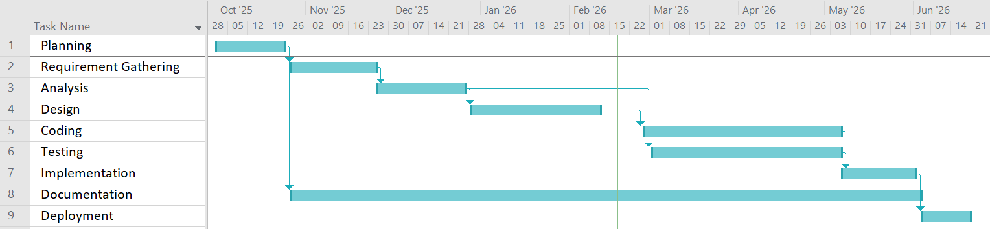
Figure 1: Gantt Chart
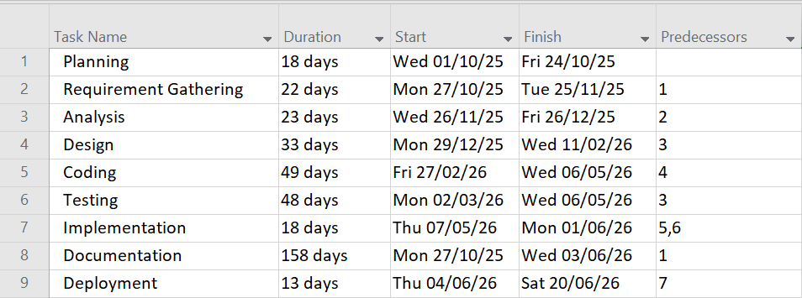

Chapter 2
Literature Review

2.1.Literature Survey
Mobile technology has changed how kids learn. Educational apps use games, videos, and interactive tasks to make lessons fun. In Islamic education, digital tools are great for teaching things like Quran recitation, daily prayers (duas), and good manners in a way that keeps kids interested.
Research shows that kids stay more motivated when they can interact with their lessons rather than just sitting and listening. However, for an app to actually work, it needs more than just bright colors, it needs a clear structure, helpful feedback, and a way to track how much the child has learned.

2.2.Related Work:
TajweedMate:is only designed for learning tajweed but it does not provide a structured step-by-step learning approach from beginner level. It also lacks detailed pronunciation feedback and and integration of multiple Islamic learning modules. The content is limited and too basic for comprehensive learning.
Muslim Kids Series:application focuses mainly on supplications but does not organize them into clear categories. The absence of structured classification makes it difficult for children to navigate and learn systematically. Additionally, the app provides limited interactive features and learning support.
Duolingo:is a well-designed and child-friendly educational application, its content is not aligned with Islamic or religious learning needs. Many features are also available only in the premium version, which restricts full access for all users.

2.3 Gap Analysis

Most current Islamic apps are frustrating because they don't have a clear step-by-step plan for beginners and often lock the best features. They usually require Wi-Fi to work and don't actually tell a child if they are pronouncing words correctly. Our application fixes this by offering a free, all-in-one platform that works in both online and offline mode, giving kids smart feedback and a structured way to learn from scratch.While there are many Islamic apps available, they often lack the smart features and offline support kids really need. This project aims to bridge that gap by building a single, easy-to-use platform that makes learning Islam interactive, personalized, and accessible anywhere.
2.4 Proposed Solution
The proposed application, KidsIslamicHub, addresses these gaps by providing a step-by-step learning approach from beginner level with structured modules. It includes intelligent feedback on user pronunciation, categorized supplications, and engaging audio-visual lessons. The system is designed with a child-friendly interface to enhance motivation and understanding. Additionally, it offers full free access and offline support, making it practical and accessible for young learners.

2.5 Summary:
This chapter explored how kids use apps to learn about Islam. We found that while many apps exist, most are missing a clear step-by-step plan and don't tell kids if they are actually doing a good job. Many are also messy or stop working without Wi-Fi. Because of these issues, there is a real need for an "all-in-one" app that is easy for kids to use. Our project fills these gaps by creating a fun, organized, and smart platform that works anywhere, even offline.

Chapter No 3

Software Requirements Specification

3.1. Requirements Analysis
This chapter focuses on requirement identification, elicitation and analysis. The users are categorized into two classes. For requirement identification and elicitation, ethnography, and use case analysis are used. Also identified requirements are categorized into functional and non-functional requirements, along with their use case description and diagram

3.2. User classes and characteristics
Table 5:User classes and characteristics
The Kids Islamic Hub will have two user classes, End user and Admin.

User classes | Characteristics
End user | - Age Group 6-12 years  - Basic reading and writing skills  - Learn better through small lessons and quick feedback.  - Can easily interact with buttons and audios
Admin | Admins will the specific people who can:  - Manage app content & future settings  - Manage users  - Ensure that the uploaded content is correct & Islamic  - Can troubleshoot and update the app whenever needed  - Manage notifications

3.3 Requirement Identifying Technique
There are fundamental approaches used to identify requirements.

3.3.1 Ethnography or Observation
Software systems do not exist in isolation. They are used in a social and organizational environment, and software system requirements may be generated or constrained by that environment. Ethnography is an observational technique that can be used to understand operational processes and help derive requirements for software to support these processes.

3.3.2 Use Case and Scenarios
Developing use cases and scenarios to describe how the system will be used in different situations. This technique helps in understanding the interactions between users and the system, making it easier to identify and document functional requirements. Use cases are a way of describing interactions between users and a system using a graphical model and structured text.

3.4 Functional Requirements
This section describes the functional requirements of the system expressed in the natural language style. This section is typically organized by feature as a system feature name and specific functional requirements associated with this feature.

3.4.1 Functional Requirement 1
Table 6:Functional requirement specification for Authentication
Identifier | FR-01
Title | Email-password/google sign up
Requirement | End user will be able to register an account via valid Email-password or authentic google account
Source | Business requirement
Rationale | User can create account via strong Email-password or authentic google account
Business Rule | - Password must be alpha-numeric and must contain at least 8 character.  - Existing account must be secure.
Dependencies | User must have an active internet connection and must have an existing account for google sign Up
Priority | High

Identifier | FR-02
Title | Email-password/google sign in
Requirement | User will be able to sign in via google account or by entering email and password then tapping sign in
Source | Business requirement
Rationale | Provides a secure environment
Business Rule | Must have an existing account
Dependency | User must have an active internet connection and valid existing account
Priority | High

3.4.2 Functional Requirement 2
Table 7:Functional requirement specification for password reset
Identifier | FR-2
Title | Password reset
Requirement | The user shall be able to reset password by tapping on the forget password on Log-In screen, entering their email, and receiving a confirmation code
Source | Business requirement
Rationale | Provides a secure environment
Business Rule | Password must be alpha-numeric and contain at least eight character
Dependencies | User must have an active internet connection and an existing account
Priority | High

3.4.3 Functional Requirement 3
Table 8:Functional requirement specification for Open Tajweed Lessons
Identifier | FR-3
Title | Open Tajweed lessons
Requirement | The Application must allow navigation through lessons like letters,words,rules and articulation points(Makharij) .
Source | Team research
Rationale | End user will be able to access a structured learning path.
Business Rule | Provides an interactive interface
Dependencies | FR-1,FR-2
Priority | High

3.4.4 Functional Requirement 4
Table 9:Functional requirement specification for Audio Recitation Playback
Identifier | FR-04
Title | Audio recitation playback
Requirement | End user will be able to learn tajweed using audio.
Source | Ethnography
Rationale | End user can listen, repeat and learn correct pronunciation.
Business Rule | End user will be able to download audio using an internet connection. Audio will store locally after downloading
Dependencies | FR-1,FR-2,FR3,Supabase-storage
Priority | High

3.4.5 Functional Requirement 5
Table 10:Functional requirement specification for Record Lessons
Identifier | FR-05
Title | Record lessons
Requirement | End user will be able to record their voice to practice letters & words using microphone
Source | Ethnography
Rationale | Helps user to verify pronunciation
Business Rule | Recorded audios will not store
Dependencies | FR-3,FR-4
Priority | Medium

2.4.6 Functional Requirement 6
Table 11:Functional requirement specification for Feedback
Identifier | FR-06
Title | Feedback
Requirement | End user will be able to get feedback of recordings
Source | Ethnography
Rationale | Helps user to verify pronunciation
Business Rule | Text-based feedback
Dependencies | Audio recording
Priority | high

3.4.7 Functional Requirement 7
Table 12:Functional requirement specification for Reward System
Identifier | FR-07
Title | Reward System
Requirement | End user shall be able to get badges and stars after the lesson completion
Source | Ethnography
Rationale | Helps children to get motivated
Business Rule | Rewards will be provided after task completion
Dependencies | Lesson Completion
Priority | Medium

2.4.8 Functional Requirement 8
Table 13:Functional requirement specification for Open Supplications Categories
Identifier | FR-08
Title | Open Supplication categories
Requirement | End user will be able to select supplication categories like travelling,sleeping,eating,and walking etc.
Source | Hadith
Rationale | It provides easy browsing for End user..
Business Rule | Every dua must be categorised into one category
Dependencies | FR-1,FR-2
Priority | High

2.4.9 Functional Requirement 9
Table 14:Functional requirements specification for Open Manners Categories
Identifier | FR-9
Title | Open manners categories
Requirement | End user will be able to learn Islamic manners like greeting,sharing,honesty,and speaking truth
Source | Islamic curriculum
Rationale | It helps to children in strong character building
Business Rule | Only offline audio files are used
Dependencies | FR-1,FR2,
Priority | High

3.4.10 Functional Requirement 10
Table 15:Functional requirement specification for Listen Supplications and Manners
Identifier | FR-10
Title | Listen supplications and manners
Requirement | End user will be able to listen to supplications and manners.
Source | Team research
Rationale | Correct pronunciation of supplications and better understanding of manners
Business Rule | Supplications and manners can listen only
Dependencies | FR-9,supa-base storage
Priority | Medium

3.4.11 Functional Requirement 11
Table 17 Functional Requirement specification for Add to favourite
Identifier | FR-11
Title | Add to favourite
Requirement | End user will be able add their favourite supplications and manners into favourite list
Source | Team research
Rationale | Easy access of their favourite lessons
Business Rule | Supplications and manners can added only to the favourite
Dependency | FR-8,FR-9
priority | Medium

3.4.12 Functional Requirement 12
Table 16:Functional requirement specification for Admin Dashboard
Identifier | FR-12
Title | Admin Dashboard
Requirement | To manage system functionalities through admin dashboard
Source | Team research
Rationale | For easy content handling, audio upload,user and notification management
Business Rule | Only admins can make changes
Dependency | FR-2
Priority | High

3.5 Non-Functional Requirements
This section specifies nonfunctional requirements other than constraints, supporting requirements recorded in the Functional Requirements section, and external interface requirements.
3.5.1. Reliability
This system should operate in offline mode 80% for the learning modules.Internet connectivity should not be required for normal usage. The Internet should only be required to download audios of lessons and to fetch updated lessons.
This system should focus on MTBF (minimum mean time between failures) of 250 hours and recovery time for failures within 30 seconds,automatic.

3.5.2 Usability
The system shall focus on simple navigation,minimal interaction steps,audio based learning accessibility,child friendly interface,fast screen response within 3 seconds and partially offline usability.

3.5.3 Performance
The app should load splash screen module within 3 seconds.Audios should load within 5 second over a standard internet connection

3.5.4 Security
The system shall protect learner data from unauthorized access and ensure role-based access.

3.6 External interface requirements
This section provides information to ensure that the system will communicate properly with users and with external hardware or software elements.A complex system with multiple sub-components should create a separate interface specification or system architecture specification.

3.6.1. User interface requirements
The system shall provide child-friendly interface using pastel colors.
The system shall present all main modules (Tajweed, Supplications, Manners) on a home screen with large,rounded icons.All navigation icons shall be represented using simple pictures.

3.6.2. Software interface
For Database, the system will use SQLite as a local database and Supabase for authentication and for audio downloads.

3.6.3. Hardware interface
To run the system, the user device must have specification of RAM of at least 2 GB s, an Android 7.0 version, and a properly working microphone and speaker.

3.7 Use cases

Use Case#1
Table 17:Use Case analysis of User Sign up
UC Identifier | UC-1
Title | User sign up
Requirements Traceability | FR-01
Purpose | Allow users to create a new account using Email- Password or google account
Priority | High
Preconditions | - Active Internet connection.  - Valid Email ID and Google account.  - The user doesn’t have an already registered account with the same email.
Post conditions | - A new user account is successfully created and stored in the system.  - The User will be able to login automatically next time.
Actors | Child
Extends | NA
Main Success Scenario | - The User opens the app.  - The registration screen appears.  - User registers on application.  - An account is created successfully.  - The User proceeds to Login or home screen.
Alternate Flows | NA
Exceptions | - No internet connection.  - Email is not valid.  - Passwords are weak.  - User is already registered
Includes | None

3.7.2 Use Case 2
Table 18:Use Case Analysis of User Login
UC Identifier | UC-2
Title | User login
Requirements Traceability | FR-02
Purpose | Provide secure access through email,password or google sign in.
Priority | High
Preconditions | - Active Internet connection.  - User must have an already registered account.
Post conditions | User will be able to move toward the home screen.
Actors | Child & Admin
Extends | The system extends Forgot Password if the user forgot it.
Main Success Scenario | - User opens the application.  - Login screen appears.  - User sign in the application.  - System verify email or password.  - Home screen appears.
Alternate Flows | User clicks: wrong password , System offers : forgot password
Exceptions | - No internet connection.  - The user is not signed in.
Includes | None

3.7.3 Use Case 3
Table 19:Use Case Analysis of Password Reset
UC Identifier | UC-3
Title | Reset Password
Requirements Traceability | FR-03
Purpose | Allow the user to reset the password if the user forgot the previous password.
Priority | High
Preconditions | - Active Internet connection.  - User must have an already registered account.
Post conditions | - User get a link on email to reset password.  - User creates a new strong password.
Actors | Child, Admin
Extends | NA
Main Success Scenario | - User clicks: Forgot password.  - System asks for an already registered email.  - User enters email.  - System asks to send a reset link to the email id.  - User receives an email.  - User opens email and set a new strong password
Alternate Flows | User enters an UN-registered email. System offers: create a new account
Exceptions | - Link not received on email  - Weak password  - No internet
Includes | None

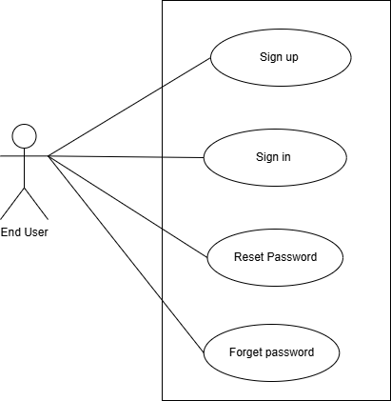
Figure 2:User Registration Use Case Diagram

3.7.4 Use Case 4
Table 20:Use Case Analysis of Open Tajweed Lesson
UC Identifier | UC-4
Title | Open Tajweed Lessons
Requirements Traceability | FR-03
Purpose | Allow User to open sorted tajweed lessons (letters,words,rules and articulation points)
Priority | High
Preconditions | User must have an already Login account.
Post conditions | Learn letters and words with tajweed rules.
Actors | Child, Admin
Extends | View lessons
Main Success Scenario | - User opens the section of tajweed lessons.  - System shows categories (Huroof, Words, rules).  - User selects any category.  - System shows the lessons list of that category.  - User clicks a lesson  - System displays lesson content  - User plays audio of the lesson.
Alternate Flows | NA
Exceptions | System fails to load the list of lessons due to missing database files.
Includes | None

3.7.5 Use Case 5
Table 21:Use Case Analysis of Audio Playback
UC Identifier | UC-5
Title | Audio Playback
Requirements Traceability | FR-04
Purpose | Allow User to play audio of tajweed lessons for correct pronunciation.
Priority | High
Preconditions | - Storage Access.  - Application must have a downloaded audio to play.  - Audio only downloaded if there is internet connection.
Post conditions | If audio is downloaded at 1 time, audio is saved locally for offline use.
Actors | End User, Admin
Extends | NA
Main Success Scenario | - User opens the section of tajweed lesson.  - User clicks on speaker button  - If the user is online, audio will download successfully, then user can play the audio offline anytime .
Alternate Flows | NA
Exceptions | Audio will never play if there is no internet connection.
Includes | None

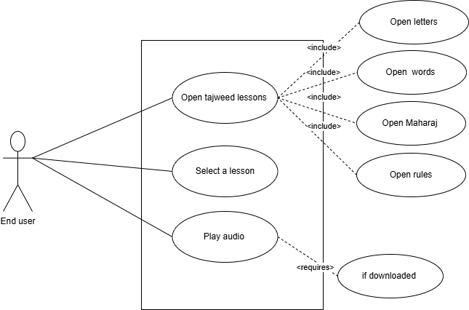
Figure 3:Tajweed Lessons Use Case Diagram

3.7.6 Use Case 6
Table 24 use case 6
UC Identifier | UC-6
Title | Record Tajweed Lesson
Requirements Traceability | FR-5
Purpose | Allow User to record audio of tajweed lessons to improve pronunciation by practicing.
Priority | High
Preconditions | Microphone access permission.
Post conditions | Audio is not stored permanently.
Actors | Child
Extends | NA
Main Success Scenario | - User opens the section of tajweed lesson.  - User clicks on mic button.  - User can record a voice either in an online or offline way.  - User speaks the letter or word, then stop, system provide a feedback.
Alternate Flows | User denies permission,System shows: “Allow microphone access”
Exceptions | Microphone is not available
Includes | None

3.7.7 Use Case 7
Table 22:Use Case Analysis of Tajweed Lesson Feedback
UC Identifier | UC-7
Title | Tajweed Lesson Feedback
Requirements Traceability | FR-06
Purpose | To improve the pronunciation, user gets a text based feedback
Priority | Medium
Preconditions | - User has recorded their lesson practice.  - Microphone and recording module are available.
Post conditions | Feedback is displayed after analysis.  User can record a lesson again to increase their progress.
Actors | Child
Extends | NA
Main Success Scenario | - User completes and uploads the recording.  - System analyzes the pronunciation.  - The system displays visual text based feedback.(e.g 70% correct. Keep it up).
Alternate Flows | User repeats recording to get improved feedback
Exceptions | - Microphone not accessible.  - Feedback module fails.
Includes | None

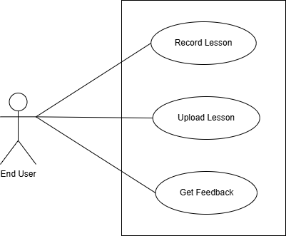
Figure 4:Lesson recording Use Case Diagram

3.7.8 Use Case 8
Table 23:Use Case Analysis of Reward System
UC Identifier | UC-8
Title | Reward system
Requirements Traceability | FR-07
Purpose | To motivate children by giving badges and stars after completing Tajweed lessons.
Priority | Medium
Preconditions | User has completed a lesson
Post conditions | - Rewards are updated in the user profile.  - User sees badge/star on the dashboard.
Actors | Child
Extends | NA
Main Success Scenario | - User finishes a lesson.  - System checks completion criteria.  - System awards badges/stars.  - User sees reward notification.
Alternate Flows | If User does not complete the lesson,then no reward is given.
Exceptions | Reward module not responding
Includes | None

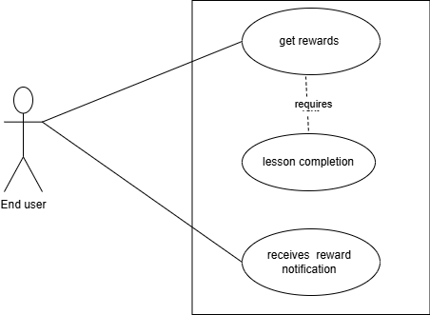
Figure 5:Earn Reward Use case Diagram

3.7.9 Use Case 9
Table 24:Use Case Analysis of Open Supplication Category
UC Identifier | UC-9
Title | Open supplication category
Requirements Traceability | FR-08
Purpose | Allow User to view multiple Supplications related to our daily life(e.g. travelling, eating, drinking)
Priority | High
Preconditions | The user is logged in.
Post conditions | User can select and open supplications from a category.
Actors | Child  Admin
Extends | NA
Main Success Scenario | - User opens the Supplications section.  - System shows categories.  - User selects a category.  - System displays supplications list.  - User selects a dua to read/listen.
Alternate Flows | If Category is empty, system shows “No supplications available.”
Exceptions | Local database is not working
Includes | None

3.7.10 Use Case 10
Table 28 use case 10
UC Identifier | UC-10
Title | Open Manners category
Requirements Traceability | FR-09
Purpose | Teach children basic Islamic, social and personal manners
Priority | Medium
Preconditions | Islamic manners content must be available in the local database.
Post conditions | The user successfully views the selected manners.
Actors | Child
Extends | NA
Main Success Scenario | - The user opens the Manners section.  - The system displays available manners (greeting, sharing, honesty, truthfulness, etc.).  - User selects a topic  - The system shows text explanations and audio.  - The user learns the manners content.
Alternate Flows | Audio file is missing, system only shows text and visuals
Exceptions | Content is not loading due to some error
Includes | None

3.7.11 Use Case 11
Table 25:Use Case Analysis of Listen Supplication and manners
UC Identifier | UC-11
Title | Listen Supplications and manners
Requirements Traceability | FR-10
Purpose | Allow user to listen supplications and manners
Priority | Medium
Preconditions | User browsed supplications
Post conditions | Selected supplication and manners are played
Actors | Child
Extends | NA
Main Success Scenario | - The user taps on a supplication or manner.  - The system checks if audio is downloaded.  - If yes ,then play audio.  - If not, then download from Supabase and play.
Alternate Flows | User is offline Audio not downloaded, System shows “connect to internet to download audios”
Exceptions | No internet connection
Includes | None

3.7.12 Use Case 12
Table 26:Use Case Analysis of Add to favourite
UC Identifier | UC-12
Title | Add to favourite.
Requirements Traceability | FR-11
Purpose | Allow children to add their favourite supplications and manners for quick access later.
Priority | Medium
Preconditions | Supplication & manner must be available in the list of supplications and manners respectively.
Post conditions | - Supplication or manner is successfully added to the user’s favorites list.  - Updated favorites list is stored in the local database.
Actors | Child
Extends | NA
Main Success Scenario | - The user taps on a supplication or manner.  - User select a supplication or manner.  - User clicks: add to favourite.  - System updates favorite items list.  - System shows confirmation message
Alternate Flows | - Supplication or Manner is already in the Favourite items list. System displays:- “Already added to favourites”
Exceptions | Storage is full
Includes | None

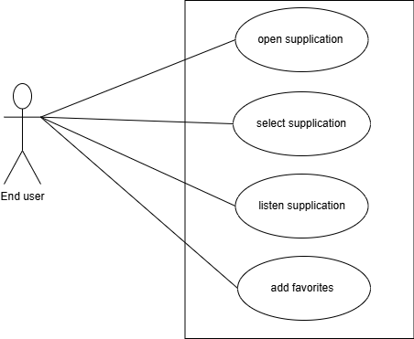
Figure 6:Open Supplication Use Case Diagram

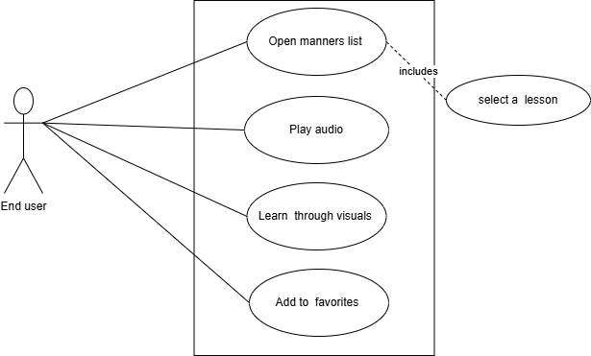
Figure 7:Open Manners Use Case Diagram

3.7.13 Use Case 13
Table 27:Use Case Analysis of Notification
UC Identifier | UC-13
Title | Notifications
Requirements Traceability | FR-12
Purpose | Notify users about lesson updates, new content, or reminders.
Priority | Medium
Preconditions | User has allowed notifications.
Post conditions | User successfully views the selected manners topic.
Actors | Child, Admin
Extends | NA
Main Success Scenario | - Admin generates a notification (new lesson, reward).  - Admin sends notification through Firebase Cloud Messaging.  - User receives notification on the device.
Alternate Flows | User has turned off notifications , system will log the notification event
Exceptions
Includes | None

3.7.14 Use Case 14
Table 28:Use Case Analysis of Admin access control
UC Identifier | UC-14
Title | Admin access control
Requirements Traceability | FR-12
Purpose | Allow administrators to manage admin accounts securely.
Priority | Medium
Preconditions | Admin is logged in.  Firebase authentication is active.
Post conditions | New admin is added or any existing admin is removed
Actors | Admin
Extends | NA
Main Success Scenario | - Admin opens the Admin Panel.  - Admin selects “Manage Admin Accounts.”  - Admin adds a new admin email OR removes an existing one.  - Firebase updates the admin account list.  - System confirms the success
Alternate Flows | Audio file is missing, system only shows text and visuals
Exceptions | Content is not loading due to some error
Includes | None

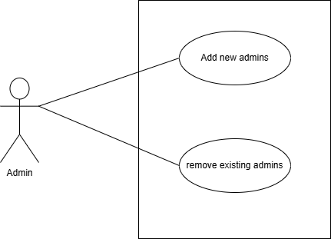
Figure 8:Admin access Control Use Case Diagram

3.7.15 Use Case 15
Table 29:Use Case Analysis of Managing Learning Modules
UC Identifier | UC-15
Title | Manage Learning Modules
Requirements Traceability | FR-12
Purpose | Allow administrators to add,edit or delete the learning modules
Priority | High
Preconditions | - Admin is logged in.  - Sqlite database connected.
Post conditions | Updated content stored in local database.
Actors | Admin
Extends | NA
Main Success Scenario | - Admin opens “Learning Module Management.”  - Admin selects Add, Edit, or Delete modules.  - Admin enters details or updates content.  - System saves changes in the database.  - System shows confirmation.
Alternate Flows | - If Module already exists, System alerts the admin.  - If Admin leaves required fields empty, the system asks to complete fields.
Exceptions | - Database write failure.  - Invalid module data.
Includes | None

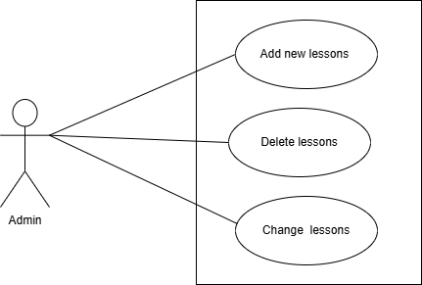
Figure 9:Manage Learning Modules Use Case Diagram

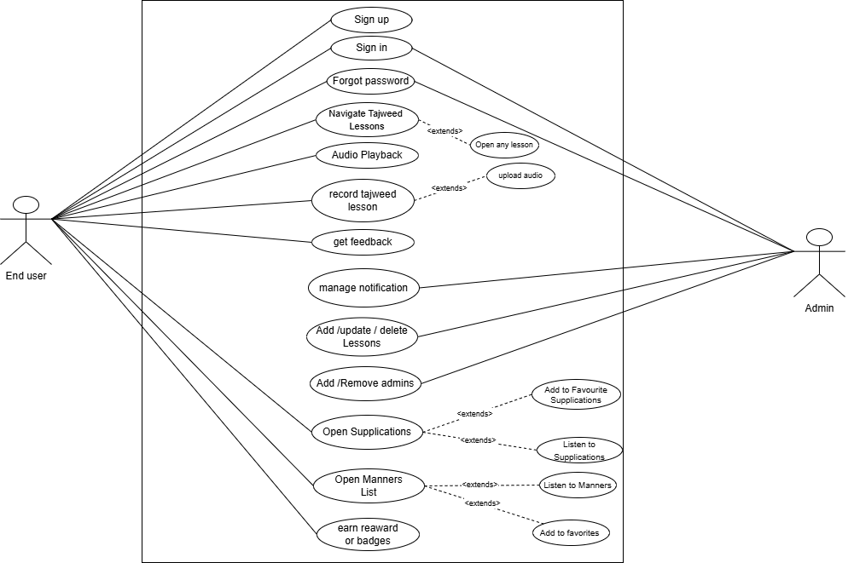
Figure 10:Sytem Use case Diagram

3.8 Story boards:
Tajweed screen:
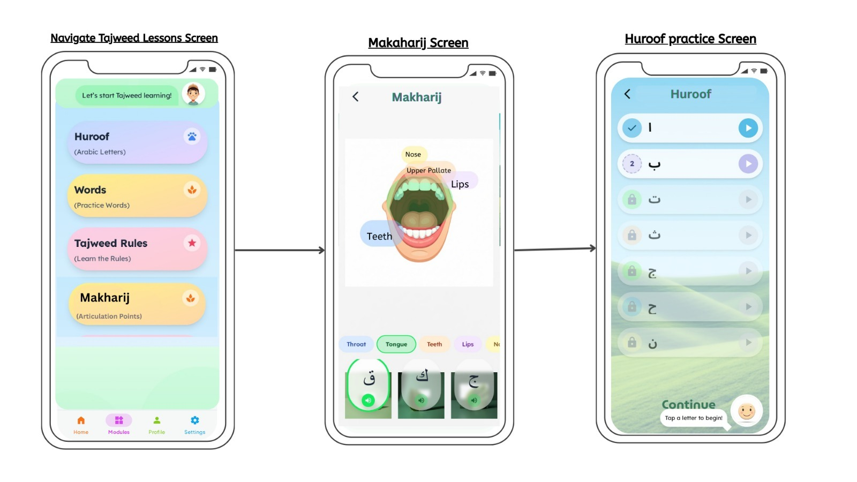

Supplications screen:
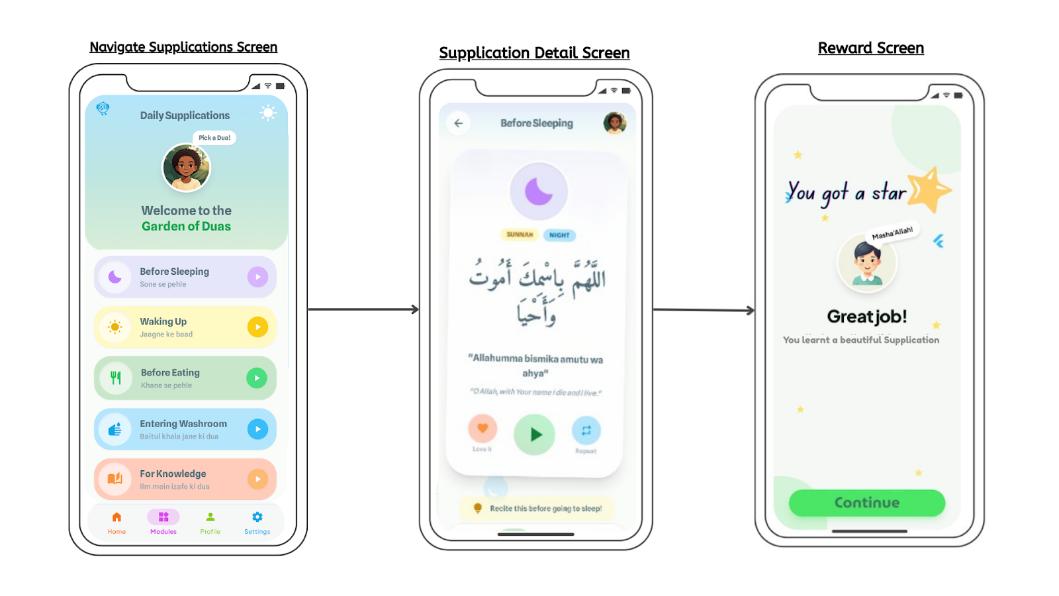

Manners screen:
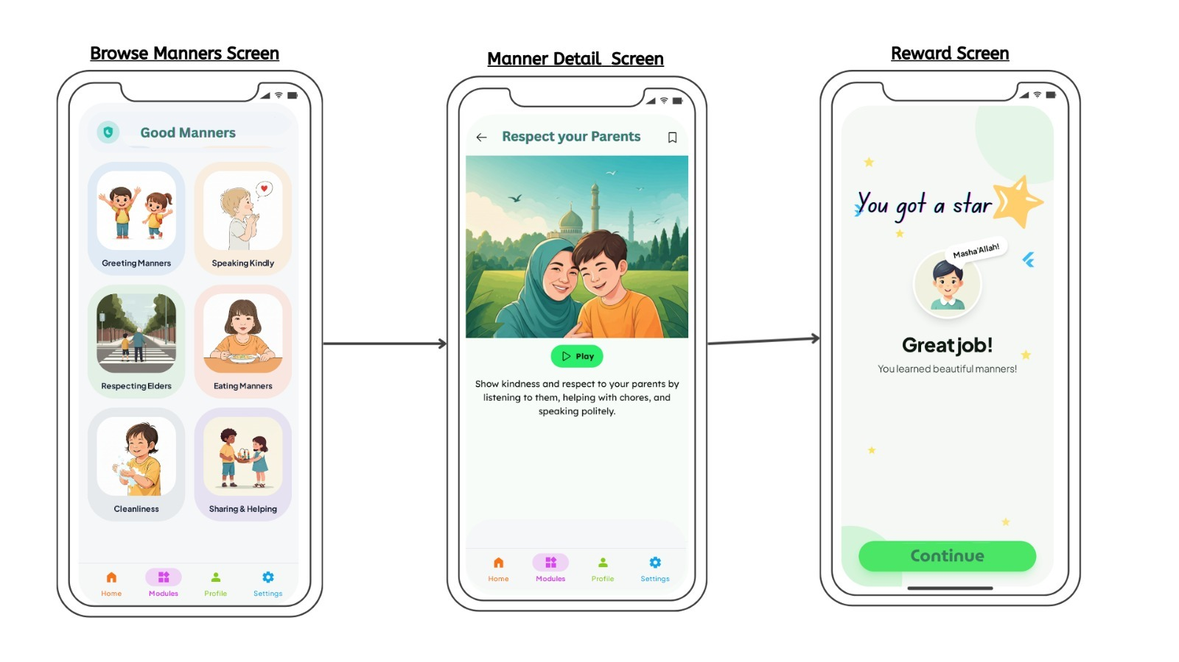

Summary :
This chapter outlines the process of identifying, eliciting, and analyzing system requirements. Users are divided into two main categories. To gather requirements, techniques such as ethnographic observation, and use case analysis are applied. The collected requirements are then classified into functional and non-functional types, supported by detailed use case descriptions and diagrams.

Chapter4

Software Design Specification

4.1 System Design
This chapter focuses on system design and its analysis in depth. From design considerations to design models and architecture design, everything is provided in high level abstract model diagrams. The models included sequence, state, class and component diagrams are included. The architecture pattern used is MVP due to its easy understanding and test-ability

4.2Design Considerations

4.2.1 Assumptions and Dependencies:
Following assumptions and dependencies were considered, the user will have stable internet connection, the user will have an android 7.0+ version, the user will have google play services installed, a RAM of at least 2GB, and free storage of at least 1 GB. Mostly assumptions, dependencies and limitations are listed in chapter 1.
4.2.1 Limitations:
The system depends on limited audio recording facility that is just for tajweed module recording.Stable internet connection for audios downloading.

4.2.3 Risks:
The risk possessed by our system is the limitations of offline audio storage.
Offline storage of audios can slow down the system’s performance .To curb this we use an approach in which we are using supa-base for online audio storage and after downloading the audios cached to the local db.

4.3 Requirement Traceability Matrix:
Table 30:Requirement Traceability Matrix
Requirment ID | Scope | Requirment Description | Design Specification
R1 | User Registration &Login | The system shall allow users to register,login, and authenticate securely using email/password or Google Sign in. | Component: Authentication Module(Supabase Auth).
R2 | Role Based Access | The system shell provide role based access control(Student /Admin) and redirect users to the appropriate dashboard after login. | Components : Access Control&Dashboard Module.
R3 | Tajweed Letters Learning | The system shell display 29 Arabic letters with audio pronunciation and allow users to record their voice for practice. | Component: Letters Learning Module.R4
R4 | Tajweed Word Practice | The system shell provide a list of tajweed words with correct audio pronunciation and recording funcationality. | Component: Word Learning Module.
R5 | Tajweed Rules | The system shell explain tajweed rules with examples and audio demonstration. | Component: Rules Module
R6 | Makharij(Articulation Points) | The system shell display five articulation points with related letters and words,along with audio lessons and recording option. | Component: Makharij Module
R7 | AI Pronunciation Feedback | The systen shell analyze recorded audio and provide AI based feedback in the form of stars and badges. | Component: AI Feedback Engine
R8 | Offline Audio Access | The system shell allow to download and play tajweed audio lessons offline. | Component: Local Storage Module(SQLite)
R9 | Progress Tracking | The system shell allow user learning progress and completed lessons. | Component: Progress Tracking Module(Supabase +SQLite)
R10 | Password Recovery | The system shell allow users to to reset their password via email verification. | Component: Authentication Module(Supabase Auth)
R11 | Google Authentication | The system shell support login via Goole authentication for quick access. | Component: Authentication Module (Supabase Auth)

4.4Design Models:
The system model represents the application’s different views or perspectives. Such models are used to convey the bird eyed view of application to other stakeholders. It is important to understand that a system model is not a complete representation of a system. It purposely leaves out detail to make it easier to understand. A model is an abstraction of the system being studied rather than an alternative representation of that system. A representation of a system should maintain all the information about the entity being represented. An abstraction deliberately simplifies a system design and picks out the most salient characteristics. The Use Case Modeling is given in chapter two and remaining models will be discussed here.

4.4.1Design Class Diagram
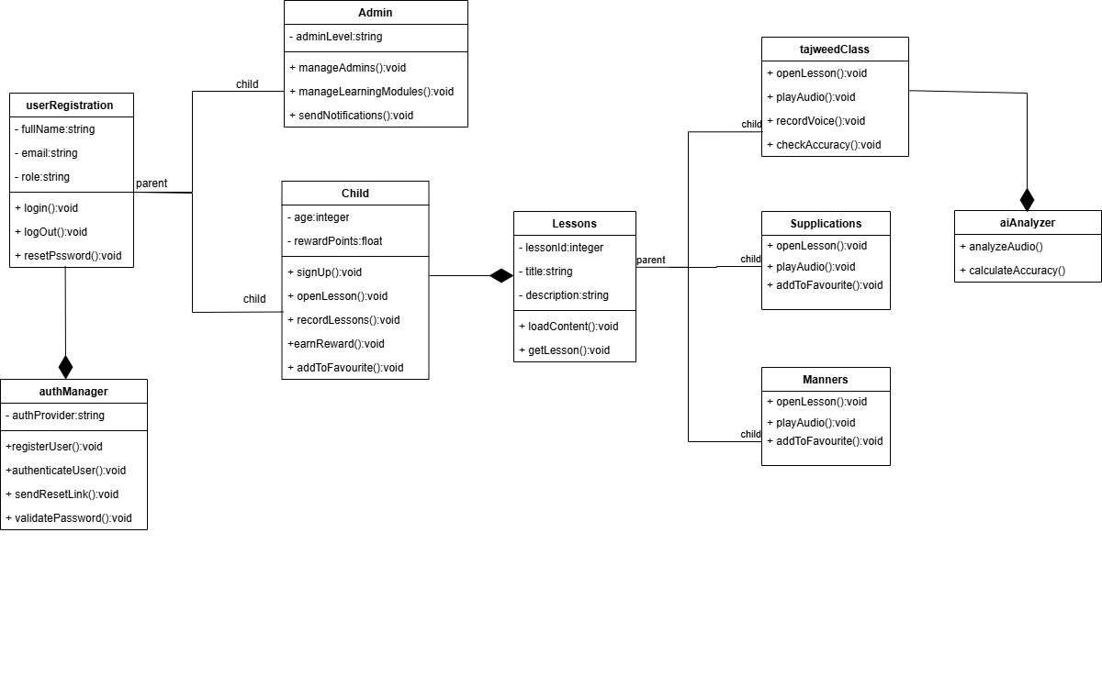
Figure 11:Design Class Diagram

Figure 3- 1 Class Diagram

4.3.2 Sequence Diagram
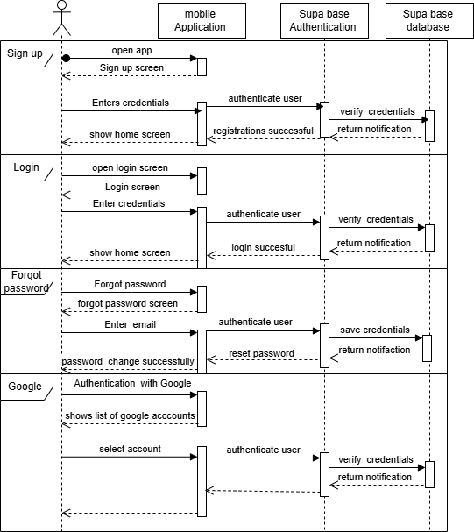
Figure 12: Authentication Sequence Diagram

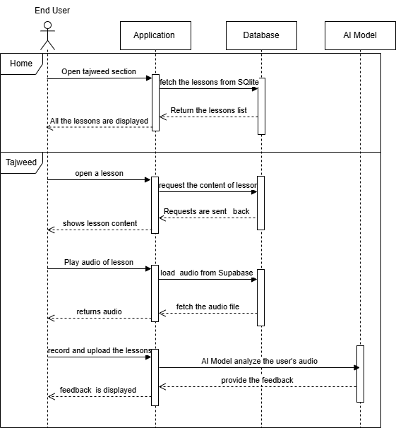
Figure 13:open tajweed lesson sequence diagram

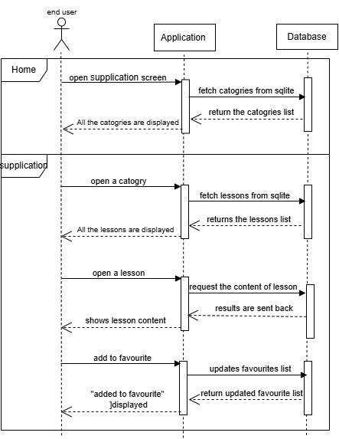
Figure 14:Open supplication sequence diagram
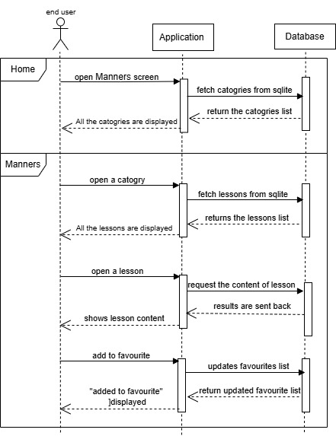
Figure 15:Open Manners Sequence Diagram

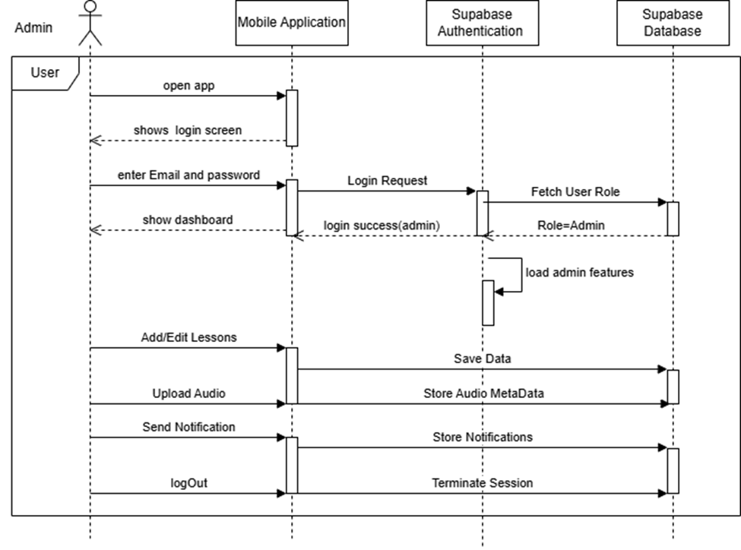
Figure 16:Admin dashboard sequence diagram

4.3.3 State Diagram
- Authentication State diagram:

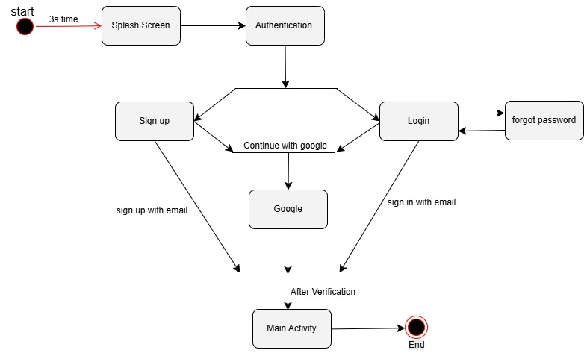
Figure 17:Authentication state diagram

- Tajweed state diagram:

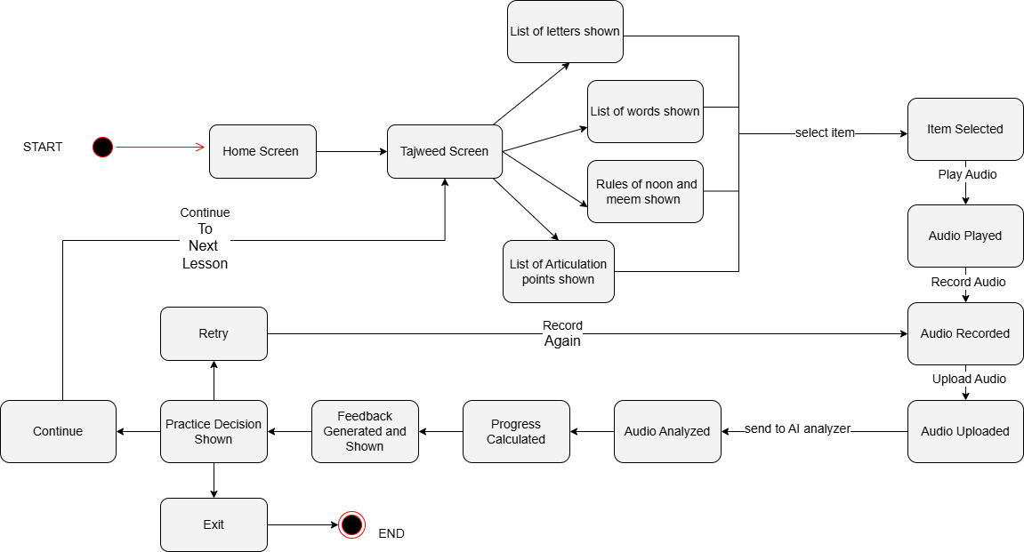
Figure 18:Tajweed state diagram

- Supplication state diagram:

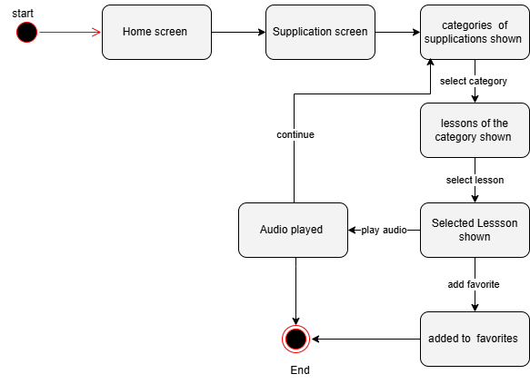
Figure 19:Supplication state diagram

- Manners state diagram:

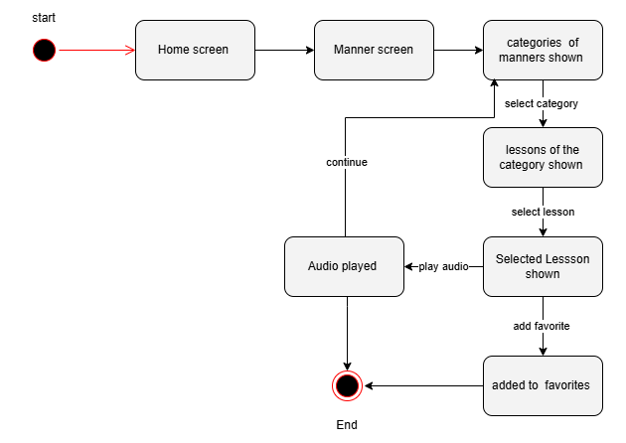
Figure 20;Manners state diagram

4.3 Architectural Design
Architectural design is concerned with understanding how a software system should be organized and designing the overall structure of that system. Architectural design is the first stage in the software design process. It is the critical link between design and requirements engineering, as it identifies the main structural components in a system and the relationships between them. The output of the architectural design process is an architectural model that describes how the system is organized as a set of communicating components.

4.3.1 Component Diagram
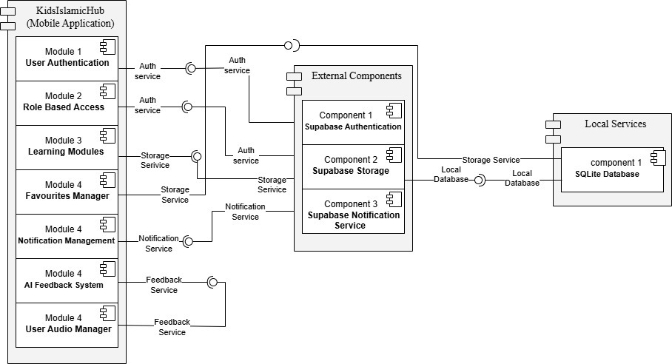
Figure 21:Component diagram

4.3.2 Architecture Pattern Diagram
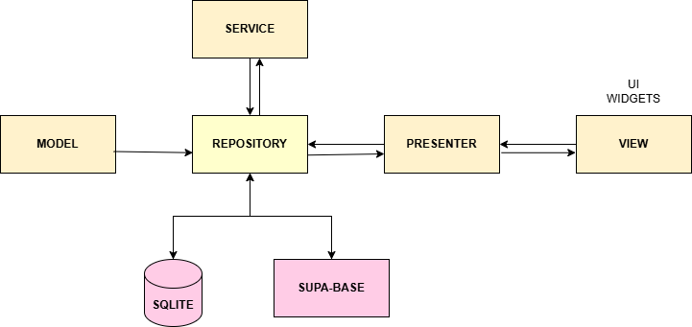
Figure 22:Architectural Pattern Diagram

4.4 Data Design
The system uses Supabase as the centralized backend.
Structured data such as courses, modules, lessons, and metadata are stored in a PostgreSQL database. Media content including audio and visual files is stored separately in Supabase Storage.
To support offline usage, a local SQLite database is implemented on the client side.
Frequently accessed data is cached locally, and media files are downloaded on demand.
Synchronization occurs automatically when an internet connection becomes available.
SQLite is used only to store lesson metadata and file references, while actual media files are stored in the device file system and the master copy remains in Supabase Storage.

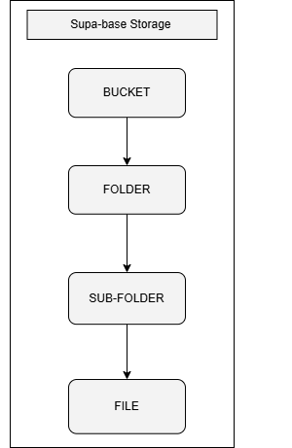
Figure 23:Supabase Storage

Below is the hierarchy of learning modules:

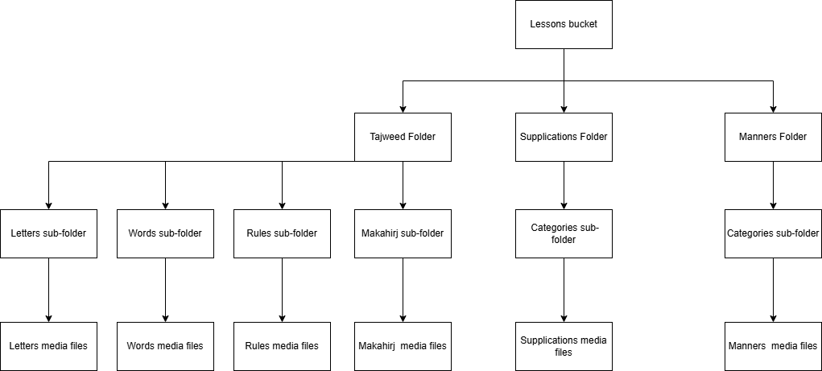

Figure 24:supabase storage hierarchy

4.4.1 Data dictionary:
Table 31:Data Dictionary
As we are using Object Oriented Approach so our Data Dictionary is comprised of Classes, major classes are given below:
Admin | Class: represents the admin.can edit lessons,manage notifications,and update audio
End user | Class: represents the user .can view and interact with lessons
Lessons | Class:used to create topic objects for easy lesson selection
tajweedRepository | Class: used to enlist tajweed lessons
supplicationsRepository | Class: used to enlist supplication categories
mannersRepository | Class: used to enlist manners category
aiAnalyzer | Class: used to analyze user audio
Letters | Class: contains list of letters
Words | Class: contains list of words
Rules | Class: contains rules of noon and meem
articulationPoints | Class: used to create a list of articulation points
favouritesList | Class: used to create list of favourite lessons
Notifications | Class: use to create notifications

The user interface is designed using figma, the whole flow of application is designed with collective efforts of team while focus

4.6 Design Decisions
For architecture we use MVP pattern because it is easy to implement,testable,and modular.
For databases we use supa-base which is postgresql based object oriented data base.

4.7 Summary
This chapter presents a detailed analysis of the system design, covering design considerations, architectural structure, and high-level abstract models. It includes sequence, state, class, and component diagrams. The MVP architecture pattern is used for its simplicity and ease of testing.

REFERENCES
Tajweed Mate — Play Store link:
https://play.google.com/store/apps/details?hl=en_US&id=com.tajweedmate.androidapp Google Play
Duolingo — (General link)
https://play.google.com/store/apps/details?id=com.duolingo
Muslim Kids Series: Dua — App Store link:
https://apps.apple.com/us/app/muslim-kids-series-dua/id429158607 Apple
Muslim Kids TV (similar / related) — Play Store link:
https://play.google.com/store/apps/details?hl=en_US&id=com.mktv.steelkiwi.muslimkidstv

